(ip.src == 192.168.43.0/24 and ip.dst == 192.168.43.0/24) or (ip.dst == 192.168.43.0/24 and ip.src == 192.168.43.0/24)

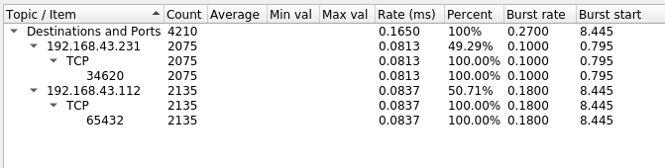

**Server client messages:**Server 192.168.43.112

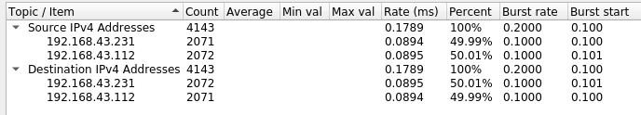

**Server client TCP ack spam.**

**Whenever a package is detected from the client (231) to the server (112), we send 3 acks back to the client. We see that there’s a discrepancy between the number of packages sent from the client and the server.**

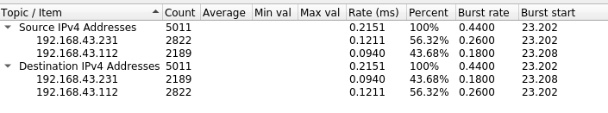

**Server client TCP restart transmission spam.**

The server Is here sent to timeout the connection if no packages is received from client in 3 seconds, and after this required a new connection. We see that a lot more packages are sent to the server (112), than there are packages sent to the client (231).

This is due to the connection being terminated.

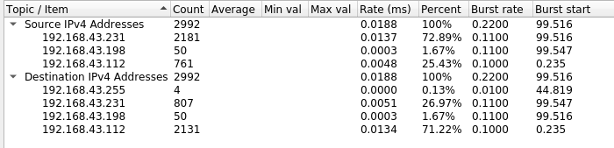

**Now we try to time the function with a specific number of packages.**

**1000 packets:**

**No ack: 11.105501174926758 seconds**

**3 acks: 11.268192529678345seconds**

**Restart:**